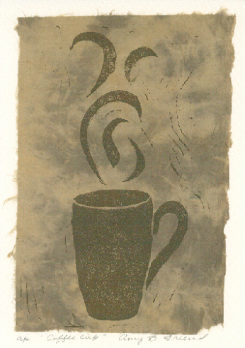

Free Recipes

for your pleasure
Espresso is several things all at once. It is a unique method of coffee brewing of fine ground beans roasted darker brown than the American roast "good for the soul" Yet, people are as numerous as they are diverse and therefore the following should only be used as a guide while experimenting with other variations to meet the consumers needs:

Cappuccino  (Italian) | A mix of an equal amount of espresso and steamed milk, served in a demitasse cup topped with rich, thick milk foam.
Cappuccino  (American) | Espresso, mixed with rich steamed milk and foam.
Café Latte | Espresso, mixed with rich steamed milk and topped with milk foam poured down the middle.
Café Mocha | Espresso, rich sweet gourmet chocolate mixed with steamed milk and topped with whipped cream.
Americano | A mix of espresso and hot water.
Espresso | A single shot of espresso (1 oz. to 1-1/2 oz.) served in a demitasse cup with sugar on the side.
Espresso Romano | Espresso served with a twist of thin slice of lemon.
Espresso Macchiato | Espresso, marked(macchiato) with a small amount of milk foam.
Espresso Con Panna | Espresso with whip cream on top.
Café Breve | Same as latte, except with half and half milk.
Ristretto | Restricted: 3/4 oz. espresso.
Lungo | Long: 1-1/2 oz. to 2-1/4 oz. espresso.
Doppio | Double: 2 to 3 oz. espresso using a double filter.
Iced Latte | Ice, milk and espresso poured on top.
Iced Mocha | Ice, milk mixed with sweet gourmet chocolate, espresso and whipped cream on top.
Iced Breve | Ice, approximately 2 oz. of Italian flavor and seltzer, whipped cream optional.
Italian Crème Soda | Same as above, plus 1/2 oz. half and half
Flavored Steamers | Steamed milk with 1 oz. to 2 oz. flavor.
Hot Chocolate | Sweet gourmet chocolate with steamed milk and topped with whipped cream.

